THE SYSTEM DYNAMICS RESEARCH OF R&D AND INNOVATION STRATEGY FORMATION

Iuan-Yuan Lu ¹, Hou-Hung Wei ²

1 Vice Chairperson of Asia Network for Quality
Professor, Institute of Business Administration,National Sun Yat-Sen University
No.70, Lien-Hai Road, Kaohsiung 804, Taiwan, R.O.C
iylu@bm.nsysu.edu.tw
2 Ph D, Student, Institute of Business Administration, National Sun Yat-Sen University
No.70, Lien-Hai Road, Kaohsiung 804, Taiwan, R.O.C

ABSTRACT
The 21st century is an era of highly competitive globalization market. Enterprises will need to weed through the old to bring forth the new products and/or services, and continue increasing Research-and-development (R&D) and technological innovative abilities in ordered to enjoy worth benefits from the international market and maintaining their competitive advantages. In this study, the main focus are managerial implications and managerial thinking, with strategy map of innovation processes, through system thinking and system dynamic theory’s modeling methods, and from the development research and innovation strategies formed by the operational environment from inside and outside of company, can help managers’ perspectives on finding suitable elements and processes about the future in planning and researching developmental resources into the development of new products/services. The key success factors (KSFs) of promoting the corporate reform and the innovative activities are the corporate leaders’ managerial philosophy, managerial assertiveness, and to achieve strategic objectives of organization development. Leaders need precisely handle current core problems, and reason and relate between the causal relationship of operational system and network. R&D and innovation strategy should follow the corporate strategy for extension, combine the needs of market demands and develop an approach to fit business activities and institutions. The new product’s characteristics should show off the innovation effects, further enhance product value, sales, profits and in return supported corporate leaders’ philosophy and reflected on the effectiveness of the implementation strategy. The carrier capacities of system model which include (1) corporate leaders’ managerial philosophy and leadership ability required to meet within met market demands of the existing industrial environment; (2) R&D and innovation strategy should be effectively increasing incomes and reducing expenditures; and (3) corporate advantages should resist competitors attack.

Key words: System dynamics, System thinking, Innovation, Leading product, Strategy maps

INTRODUCTION

The 21st century is an era of highly competitive globalization market. Enterprises will always promote the new products and/or services in the market, and continue to increase the Research-and-development (R&D) performance and technological innovations in order to enjoy the worth benefits from global market and maintain competitive advantages. However, in this competitive globalization market, it is so important to provide low-cost and better quality of products or services than competitors. Therefore, so many business management theories and applied researches have been focus on how to effectively enhance innovative ability in the project and on why corporate leaders need to put innovation strategy first in the strategic planning.

In R&D innovation activities, enterprises need to draw the long-term strategic goals, new products development and market categories, core competences and strategic assets in order to make fully networks of the value that chain with innovative resources from the world. The enterprises need to gain the greatest efficient and benefit through strategic alliances, acquisition of technological expertise, transformation and rapidly catch new technologies.

In this study, the main focuses are managerial implications and strategic thinking, combine with innovation processes of strategy map and use modelling methods through system thinking and system dynamic theory from the development research and innovation strategies by global operational environment from inside and outside of company. It can help managers’ perspectives on finding suitable elements and processes about the future in planning and researching developmental resources into the development of new products/services.

This study is to construct a set of theoretical and empirical theory of “the system dynamics research of R&D and innovation strategy formation”. Figure 1 shows the flowchart of this study. The first stage is to use Kaplan & Norton’s concept of strategy maps as the theoretical foundation of innovation process. We summarized the innovation process of strategic actions and related actions as our initial framework of innovation strategy formation. We also implement system thinking and system dynamic’s method, logical inference, and the design of causal relationship loops to infer R&D and framework of innovation strategy formation and its strategies’ causal relationships. We connect how corporate leaders conduct R&D, innovation activities, process, and other key factors to draw the causal feedback loops and to build the system model of R&D and innovation strategy formation. The second stage step, we use the secondary data, the book “Turnaround: how Carlos Ghosn Rescued Nissan” as the case study for this study. The secondary data provided the model to have variety variables’ input and output data, the causal relationship between variables, orders and feedback loops that can effectively simulate enterprises in the implementation of R&D, innovation activities and strategy formation. The secondary data can also validate the effectiveness of the system model.

The first objective is to explore the key successful factors of corporate leaders’ implementation of corporate reform, R&D and innovation activities and to identify the factors of causal relationship and strategic thinking. Based on the method of system thinking and system dynamics, and based on the key successful factors of R&D and innovative activities, factors and factors’ causal relationship and strategic thinking, to construct the causal feedback loop and system model of R&D and innovation strategy. Furthermore, the objective is to simulate many other effectiveness innovative activities and to make appropriate proposals and processes configuration for corporate leaders in thinking of investing resources in R&D and as well as the decision-marking tool for new product or service development. Finally, we use the company Nissan as the case study to summarize the strategies and variables of actions for system’s simulated input and output data and further verify the validity of the model.

LITERATURE REVIEW

The Value Proposition of Leading Product
Kaplan & Norton (2004) discuss about an important notion of corporate activities, the value proposition. We started to extract out strategies and then prepare to explain in details of strategy implementations and establish measurement standards for testing or verifying the results to reach the corporate goals. Strategy is a plan of action designed to achieve a particular goal in the enterprise. The enterprise needs corporate leaders to combine and to integrate every corporate department resources to achieve corporate goals and to maintain competitive advantages. In order to ensure the competitive advantages, the organization must be committed to continue innovation, delivery new products, services, and processes. The successful innovation can promote customer acquisition and customer growth, and therefore gained customers’ loyalty toward the company and increase corporate profits. It also can calibration opportunities, management portfolio, put new ideas in designing new project and service, make it happened and then delivering new products on the market.

The enterprise who use of leading product strategy, its value proposition focus attention is customers whom are willing to pay higher price for the distinct features and functions. These types of enterprise usually hope that their efforts on innovation or cutting edge products can lead the industry, and therefore they must focus greater attention on customer demands and provide superior products and services. The enterprises must maintain balances in the following three areas as basic research in creating science and technological breakthroughs, delivered results though new product platforms and using innovative features of derivatives products can upgrade the existing products platform.

RESEARCH METHODS

In our study, first we use strategy map of balance scorecard as our theoretic based to summarize strategic actions and relationship of innovation process to be the initial framework and identify the casual loop by system thinking and format a system model of innovation strategy by system dynamics. Second, a practical case to simulate the system model of the corporate strategy by the secondary data are based on a story in “Turnaround: how Carlos Ghosn Rescued Nissan”, Nissan and Infiniti’s official website and the company’s annual report to describe the evolution history, the factors and relationship of how corporate strategies affecting strategies, the relationship between factors, the performance data over time as the basis. In order to simulate the strategic model and confirm the validity, we observe the past track records of the forming strategy of the system model, and further experiment the future decision-making and preview the strategic performance of innovation.

Using the system dynamics theory can provide a view of systemic thinking in cases and overall view of links between them. The advantages on investigating this case study includes not just providing the research information and modeling process but also widen the scope of control variables, repeated to verify numerical input and output, and tested the relationship between variables. The output and the relationships may use longitudinal time data to facilitate the cases observation results over a period of time. The study provides widely and extensive information in cross referencing of original data to validate the accuracy.

The Leading Product Strategy of NISSAN
In 1999, Nissan has net debt about 2.6 trillion yen and declined domestic and global market shares in the industry. When Nissan alliance with Renualt in 1999, the new leader, Ghosn stepped up to the plate and foresaw that the problem in Nissan was due to the poor management. He recognized that to move Nissan forward, total transparency is the key to yield trust and stands before consumers, employees, and shareholders. The media and public had to understand Nissan’s current situation and objectives. The plans were drew, visible and invisible decisions were made such as reducing number of vehicle assembly plants, reducing global head count, breaking up the “keiretsu” to reduce purchasing costs, developing exciting new products, simplifying Nissan’s manufacturing structure and increasing in manufacturing utilization, restructuring personnel, and changing the way employees were managed and compensated.

In October 1999, Ghosn announced Nissan Revival Plan (NRP) – Returning Nissan’s short-term and long-term profitability, the plan objectives included: reduce hundreds of nonessential holdings, achieve 1 trillion yen cost reduction in global purchasing, manufacturing, and general administrative costs which included three assembly plants in Japan were to be closed by March 2001. In addition, two power train operations were to be close by March 2002 and eliminate 21,000 jobs worldwide (including more than 16,000 in Japan), reduce capacity by 30 percent, and raising the utilization rate to 82 percent by FY 2002.

Nissan’s internal financial reform was to centralizing the treasury. The global treasury consolidation reduced Nissan’s financial operation costs from 90 billion yen in 1999 to just 24 billion yen because less direct expense was needed. Nissan’s external financial reforms were breaking up the keiretsu (a traditional web of Japanese business and benchmarking), comparing costs against other companies in the industry. The Renault Nissan Purchasing Organization was formed to maintain ongoing purchasing reduction plans. Nissan would reduce purchasing costs from 60 percent to 20 percent, and the number of parts and materials suppliers would be cut almost in half from more than 1,100 in 1999 to 600 or less by the end of 2002. Nissan followed a scheme labelled “3-3-3” that would force three partners (suppliers, purchasing, and engineering) to work more closely over 3 years, working in 3 regions (Asia, the Americas, and Europe/Middle East/Africa).

Simplifying Nissan’s manufacturing structure and reducing operational cost but while developing new products and implementing new manufacturing schemes. Nissan focused from the start on rebuilding its brand, boosting research and development investment 20 percent and rolling out 22 new models for company’s future. Revival Nissan, and ultimately growth were depended upon improved model and getting new models to market. Building brand identity – establishing Nissan to become a global brand image was highest objective in the company. Japanese-based company met the definition of globalization. Building the right products at the right time and place was critical to Nissan’s future. Nissan built new plant in Canton, Mississippi one year after the NRP, to build more models in the United States, where profits and future demand are solid (Magee, 2002).

MODELING & SIMULATION

The forming paths and causal relationships of R&D and innovation strategy were summarized as Figure 1 showed how corporate leader through his/her leadership to increasing organization morale, positive culture and increase inter-departmental synergies and cooperation by using of cross-functional teams and managerial strategies. In order to stabilize the status and poison of corporate in field, the causal feedback loop also show how corporate leader able to assess the current situation and create an action plan and innovation strategy in R&D to rapidly change and implement to achieve the goal of leading products. Apply system thinking to develop the causal feedback loop of R&D and innovation strategy. Figure 2 shows the concepts of simulated system model.

Customer Satisfy
CEO Leadership
Corporate Culture
Innovation Strategies：
Recruiting, Empowerment, Collaboration, Consistency Design, Simplify Manufacturing, Strengthen R&D, Enhance Efficiency, Invest in new products & rapidity delivery.
（Carrier Capacities）
Impact of Competetors
Consumption/
Erosion of
Carrying Capacity
Protection / Maintenance
Reduce
Enhance

Figure 1 － The Causal Relationship of R&D Innovation Strategy Formation

The System Dynamics Model of R&D Innovation Strategy Formation
The study uses the system dynamics software i-think to build up the model and use as tool of data simulation. The Figure 3 shows the system dynamics modelling of R&D and Innovation strategy formation. The system design components and variables shown in Table 2, construct R&D and innovation activities related to as the five sub-system model. There are five sub-systems as leadership, corporate culture, market information, technological abilities, and products delivery. Additions, the two endogenous variables within the system are creative idea / new product concepts and customer satisfaction.

Sub-system：Information（Stock）
Support & Involve
－
－
Failure rate
(Exogenous Variable)
Competitors’ force
(Exogenous Variable)
＋
＋
－
＋
Customer Satisfy
Sub-system：Market
（Stock）
＋
＋
＋
Sub-system：Technology
（Stock）

Figure 2－ The Concept of System Loop for R&D Innovation Strategy Formation

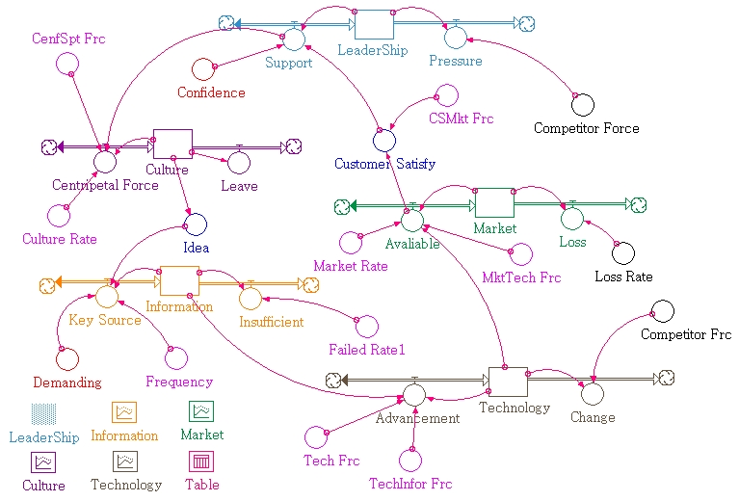

Figure 3－ The System Model of R&D Innovation Strategy Formation

In the system thinking of leadership sub-system (Leadership), CEO should balance all point views of each department and focus on target profits of whole organization to trade off implementing strategies. The trusts of business group such as boards, shareholders, investors, stakeholders, and other external groups also directly provide both positive and negative management pressures. These forces can press corporate leaders thinking about the short-term and long-term performance, policy planning, and efficiency of enterprise resource utilization that will have different strategy thinking and decision-making in the current internal and external business environments.

In corporate culture sub-system (Culture), it describes how corporate leaders through his leadership capability to efficiently allocate financial and human resources as the procedures and organization culture resources as advantages to build up competiveness in the market. It is important for the company to have employees that acknowledge with company’s corporate cultures, accept the vision of the company and unify as one to move forward. In this sub-system, the stock of Culture is affected by centripetal force of employees which encouraged by corporate leaders and culture unity as the leaders’ level of support (flow). At the same time, it also affected by operating pressure and other negative impact factors therefore further affecting levels of corporate culture changes and also alienated from the employee confidence. In the endogenous variable, creative idea / new product concepts (Idea) is also affected by Culture. That means the value of new concepts presented by employees every week represent the employees are highly motivate by corporate culture morality and it becomes the indicators of innovation and new ideas.

In marketing information sub-system (Information), it includes the key competitive information, market intelligence to knowledge-base management, patents and other corporate intangible assets. Its sub-system directly affected by creative idea / new product concepts derived from Culture. New product ideas not only come from employees but also from R&D department and mostly they come from the accumulating knowledge and technical skills in past product experiences and process. Corporate marketing information ability is supported by key corporate information. It can flow with the pace of industrial development, competitors’ progress level and sustain the nature selection in the test of time. The key corporate information includes focusing on the exploration, meeting customer demands which include how customer opinions launch a new project or new concepts and new value-added services.

In the section of sub-system of the technological innovative ability (Technology), we explain how quality, characteristic and style differences in new product or service affects consumers’ perceived value (price to pay) for products or services. In other words, because of differences in competing products and services come with different customer-specific knowledge and thus improving customer knowledge in added value for product and service has been proven to enhance customer satisfaction. To increase overall corporate R&D ability includes: technological innovative ability, functional integration, simplifying and improving manufacture process, product yield improvement and other positive reaction.

In product delivering sub-system (Market), we emphasized on the time from initial market information, to evaluate the project feasibility, prototype trial run, pass reliability test and assessment to delivering the product on the market. Managers and engineers work together in the common ground in funnel of new product development, and they also competed with each other in gaining existing corporate resources under the project development. These are the mutual assessments for each other and fasten reach the goal of delivering products to the market. When a project has been postpone, it is probably due to the delay in process links and network node, timing adjustment for customer demands, technical difficulties, leading competitor’s active progress promotes in relatively delay, and etc. The system focuses on the increasing strength in each month of technological innovation and the rate of products to be delivered on the market or off the market and reduce list of number of models per month. There is still probability of failure between delivering new product and mass production. The factors affecting the failure of new products are high manufacturing costs, lower yields, the rate of customer refunds or returns, the cost of warranty, and the difference of actual price costs. In addition to previous factors there are low customer satisfaction or even customer lawsuits, safety accidents and other environmental incidents.

Delivering new products on the market reflect that the enterprise has technological innovative ability, brand identity and well knowledge of customer demands. The quality, characteristic and style of new products or service which better than previous version and better than competitors’ will affect the higher price that customers are willing to pay and therefore will enhance customer satisfaction. Higher rate of customer satisfaction returns to support corporate leader’s leadership and promotes more employees’ internal gratification, centripetal force and corporate pride.

The System Simulation of R&D and Innovation Strategy Formation
In this study, we use “Turnaround: how Carlos Ghosn Rescued Nissan” as a case example to simulate the system. We referencing how leader Ghosn in Nissan using leadership thinking in leading product strategies, corporate culture impacts, grasp market information from R&D and decision-making process, technological innovative ability, new product attraction after delivered on the market, customer satisfaction and etc. It is the base parameters of this study “Dynamic system of business strategy and corporate value”.

In sub-system of Leadership, we explain the relationship between the company and the stakeholders such as board members, investors, bank, creditors, vendors and etc. The trust from stakeholders and customer satisfaction give the corporate leader direct positive support and negative management pressure. In this case study, Nissan previously already changed a few corporate leaders, but they were not able to fix the problems that Nissan had until Ghosn arrived. We initialized the flow of “corporate leader’s leadership” (LeaderShip) at 100 upon of Ghosn’s arrival at Nissan. The value expresses the wait-and-see attitude of board members, bank, and other stakeholders. The initial value of “External confidence” (Confidence) set at 50%. The flow of “Leaders’ level of supports” (Support) is set as Confidence * LOGN(LeaderShip) + Coustomer Satisfy * LeaderShip. The flow of “Management Pressure” (Pressure) is set as LeaderShip * Competitor Force, which is affected by the competitors.

Initially, when Ghosn’s arrival at Nissan, Nissan’s corporate culture was stuck with established practice, Japanese tradition and conservative. It was desperately need to be reformed. It was slow to response market changes and weakly grasped information of customer needs and demands, so we initialized the stock of “Corporate culture” (Culture) at 20. Corporate leader’s leadership (LeaderShip) and customer satisfaction both are directly related to centripetal force of employees and culture unity, and can be provide positive support for the corporate leader, so we set the flow of “Build up corporate culture and loyalty” (Centripetal Force) as Culture_Rate * LOGN(Culture) + CenfSpt_Frc * Support. The flow of “Employees alienation and resignation” (Leave) is set as 0.1 * Culture, which represented that management pressure will also affect the progress in building corporate culture, partially losing employees’ loyalty and etc.

Corporate culture is part of corporate intangible assets. The employees can work very efficiently and can provide positive level of support to leadership in a highly corporate culture moral. Therefore, we set the equation for conversion factor “Creative idea / New product concepts” (Idea) as 0.08 * Culture, which also provided support in the next phase, the flow of “numbers of gaining key corporate information per month” (Key Source).

From the time between initial market assessment, R&D, project design assessment, developmental new products and technological stage to products delivering on the market, engineers and managers work together in a common ground and mutually assess the existing resources invested in the project development. In the sub-system of market information, it covers the market intelligence, knowledge management, patents and other intangible assets, and also through building corporate culture and good leadership that motivates employees in creating innovative ideas, market intelligence information, R&D under the concepts of customer point-of-view and etc, therefore started proposing number of project proposals. As the project on going and the non-relative information has been eliminated, the rest of information can be converted and accumulated into the key corporate information. We initialized the stock of “market information” (Market; unit of market information) is set at 30. The equation for flow of “numbers of gaining key corporate information” (Key Source) is (Demanding + Idea) * Frequency + 0.12 * Information. The exogenous variable of “number of project proposals” (Demanding) is set at 10. The exogenous variable of “frequency of project proposals per month” (Frequency) is set at 2. The exogenous variable of “Rate of failure proposals” (Failded_Rate_1) is set at 65%. We set the equation for “Number of phase-out key corporate information” (Insufficient) as Information * Failed_Rate1, because of the importance of information is directly affects by the pace of the industrial development, competitor’s level and timing of improvement, and sustain the test of time.

In sub-system of technological innovative ability, we initialized the stock of “Technological innovative ability” (Technology) is set at 10. We set this value because there are widely technological innovative ability differences by comparing average within the industry for Nissan. The equation for flow of “technological improvements” (Advancement: number of technological improvements) is set as Technology * Tech_Frc + Information * TechInfor_Frc. The conversion factor of “technological ability that increase by key information” (TechInfor_Frc; number of technology/information) is set at 0.1. The no unit of “rate of technological improvements” (Tech-Frc) is set at 12%. It represents innovation, improvements on technological innovation ability and manufacturing which mostly come from accumulated skills, experience, and knowledge of feedback in the existing products and process. Addition in this sub-system, the equation for flow of “Lag behind technology” (Change; number of technology) is set as Technology * Competitor_Frc. The exogenous variable of “competitors’ rate of impact” (Competitor_Frc; number of rate) is set the value at 0.2. It is multiple relations with technological innovative ability means advance in technological innovative ability will decrease or even rejected by the market because factors such as technological ability of competitors’ level were higher than current technological advancement, and technology alternatives.

In sub-system of product delivery (Market), we focus the measurement of corporate performance on the number of new product types delivers on the market per month, or number of discontinue types that pull off the market. The stock of “products on the market” (Market; number of types) is set at 0. The equation for flow of “new products on the market” (Avaliable; number of type/month) is set as Market_Rate * Market + Technology * MktTech_Frc. The exogenous variable of “rate of product delivery” (Market_Rate) is set at 20%. The equation for flow of “number of products off the market per month” (Loss) is set as Market * Loss_Rate. The exogenous variable of “rate of product off the market” (Loss_Rate) is set at 60%, which represent the level of customer preferences. The value 60% is approximately the level of customer preferences in the previous month.

The equation for endogenous variable of “customer satisfaction” (customer Satisfy) is set as 0.5 + LOGN(Advaliable) * CSMkt_Frc. The conversion factor of “rate of customer satisfaction by products on the market” (CSMkt_Frc; customer satisfaction/product) is set at 0.03. It is multiple relations with nature Log of new product type delivery.

The System Validity of R&D and Innovation Strategy Formation
In the study, we use the case study of “Turnaround: how Carlos Ghosn Rescued Nissan” and focus on the new corporate leader of Nissan, Carlos Ghosn, how he reformed internal corporate structure, broke up and changed the old Japanese corporate culture and managerial styles. Figure 4 and 5 show the stock of “corporate leader’s leadership” (LeaderShip), the initial value is set at 100. Because of Ghosn’s aggressive reforms, the “corporate culture” (Culture) value rises higher related to leadership. As corporate culture grows, it enhances employees confidence and loyalty, and they willing to give all out to reach a common goal.

In “key market information” (Information) section, we initialized the value at 30. Figure 6 shows through in-depth knowledge of customer demands, awareness of past customer demands, and increasing worthy market intelligence, indicating three to six month of information depreciation. After the first six month, there is three years (36 month) of steady gain. It indicates the company Nissan’s employees have broken traditional innovation thinking, and brought forth new ideas. Additionally, by reforming internal structure, it gains more external market information and increases new ideas and experiences in department of R&D, which formats the key corporate information and gains the key market intelligence. At the same time, in response to customers’ suggestion, customer and market demands therefore launched new project, which values the patents and relative increases successful rate. Corporate innovation at the same time is under the pressure and challenge from industrial development’s movement and quality, progress of competitors, and the test of time.

In the “technological innovative ability” (Technology) section, we examined Ghosn’s robust of R&D, increases R&D expenses by 25%, simplifies manufacture processes, reduces planning time (from 60% to 5%), rapidly delivers new products on the market, focus on new model R&D and production, and delicate original 95% of time in planning to implementation. As technological expertises advanced, simplifies manufacture process, builds product quality, and buyer-specific in a framework of innovative are very important to Nissan. Figure 7 shows the corporate leader in the case study, promotes long-term goals in R&D, and optimizes technology policy leads to greater performance in technological innovation and leader in the industry, and also reflects the characteristics and differences of leading product strategy, core competitiveness and the long-term commitment.

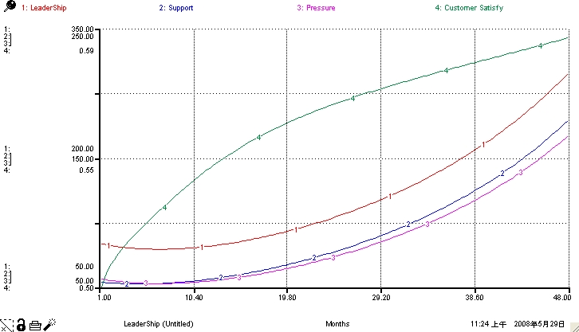

Figure 4－Simulation Result（1）

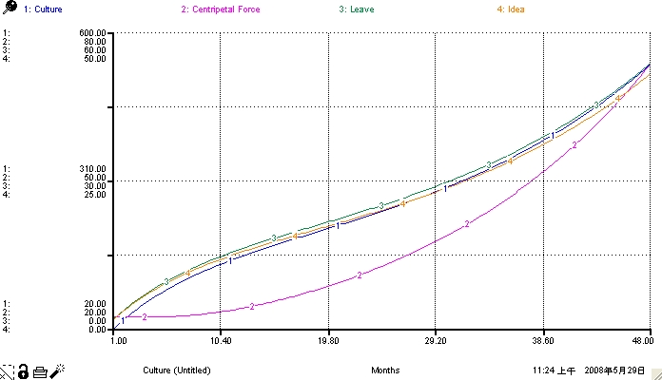

Figure 5－ Simulation Result（2）
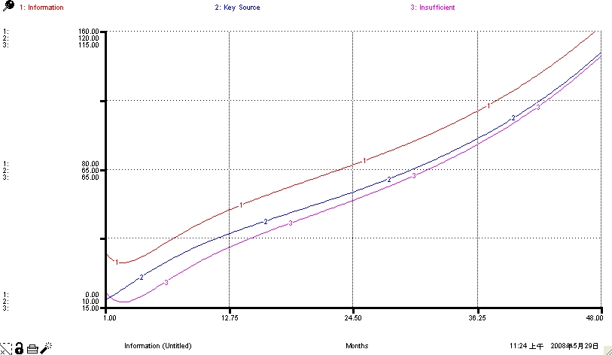

Figure 6－Simulation Result（3）

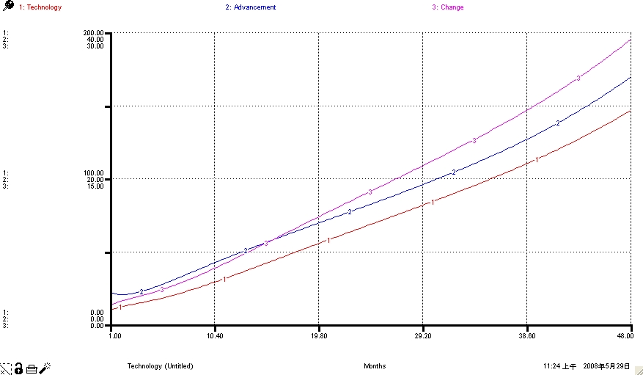

Figure 7－Simulation Result（4）

In “product delivery” (Market) section, Ghosn demands that the designers need to fully participate the product development from beginning design stage to the product delivery on the market and rapidly deliver customer feedback to R&D design department. He always focuses on Nissan’s design theme and builds manufacture plant in the world’s largest automotive consumer market, United States, in Canton, Mississippi. He takes advantages of cross-region (in Europe, the United States, and Japan) design team to design and produce unique identity style or Nissan’s models that meet customer demands and also strategically continue to develop high-performance model that reflect from the international perspective of products sales and to deliver on the market. Figure 8 shows as the technological innovation grow each month, the stock of “numbers of new products on the market” also increase. The simulated result is in line with actual performance and facts of the case study. In three years, Nissan’s twenty-two new types were rapidly seizing the visibility in the market, and continue enhancing customer satisfaction. The reforms and actions taken in technological innovative ability, brand identity, and customer-centred specification all results in good concrete outcomes. Therefore, they further feedback and support the system in the stock of “corporate leader’s leadership” and “corporate culture”.

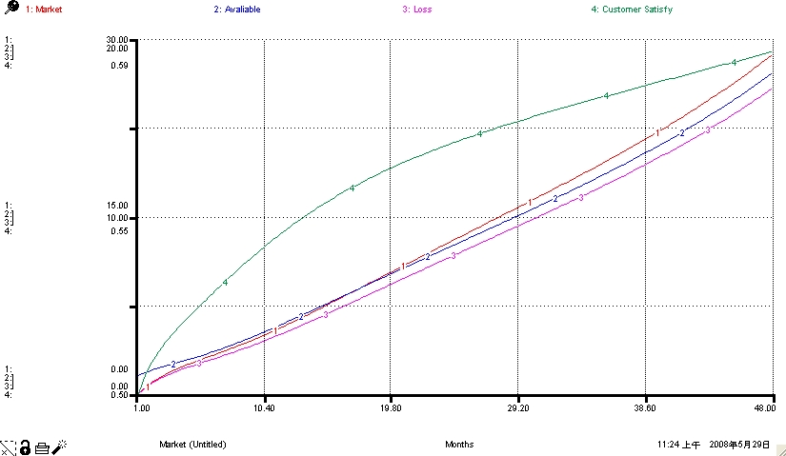

Figure 8－Simulation Result（5）

Conclusion

In our findings, the key success factors of promoting the corporate reform and the innovative activities of R&D are the corporate leaders’ managerial philosophy, managerial assertiveness, and to achieve strategic objectives of organization development. Leaders need precisely handle current core problems, and reason and relate between the causal relationship of operational system and network. R&D and innovation strategy should follow the corporate strategy for extension, combine the needs of market demands and develop an approach to fit business activities and institutions.

This study summarized how corporate leader’s leadership promotes corporate reforms and the innovative activities of R&D. We use the modeling methods of system thinking and system dynamic to examine the key successful factors, and causal relationship of factors between strategic thinking, development of R&D, and innovation strategy, furthermore develop casual loop diagram and system model using the case study, Nissan for our numerical input parameters and simulation of activities that were productive. The output of simulation validates the system with high degree of effectiveness and which match the realistic of actual conditions in the case study, therefore proves the system can be use in the matter of decision-making supportive tool of managerial thinking in investing R&D resources and development of new products or services. The case study is an example of success scenario in R&D and innovation strategy. The corporate leader in the case study, Ghosn is able to retain and precisely handle current core problems, to reason the problems, and problem-solving. He is also able to figure out the causal relationship between the operational system and network. Secondly, the leader needs to further address the core problems, the causal relationship between problems, understanding the network process, developing analytical solutions, measuring specified implementation of project plans, and time-series data. He is able to solve core problems in the order of seriousness and to implement and plan actions in an accordant way. In the implementation process of a project, the leader needs to lead by example, to reflect and attend as a team, to empower the people, to focus on implementation, and to achieve goals and objectives. The leader is able to use performance level as basis of adjusting the plan of implementation, and furthermore gaining the trust of board members, directors, shareholders, investors, employees, vendors, and etc.

The R&D and innovation strategy should able to develop suitable operation activities and system, which will show off the effectiveness of newly innovative products, improving products that are on the market and increase customer satisfaction to win back confidence of consumers. Additionally further enhances product value, sales, profits that return back confidences and supports to corporate leader’s leadership in managerial philosophy therefore reflecting the effectiveness of the implementation strategies. In system design and variables relationships, we build up a R&D and innovation activities that divided into five sub-systems are leadership (Leadership), corporate culture (Culture), market information (Information), technological abilities (Technology), and Products delivery (Market). Additions, the two variables within the system are creative idea / new product concepts and customer satisfaction. The model shows a highly degree of consistent results that match the case study’s actual conditions. This explains the logicalness of the system design and various factors that affects within each others are reasonable. It means that the system model can fully demonstrates corporate leaders’ leadership and business strategy thus bring values to its customers and even corporate profits to the table, which is a relationship of interdependent.

The impacts of R&D and innovation strategy system’s carrier capacities after simulation results are corporate leader’s managerial philosophy and leadership ability required to meet within the market demands of the existing industrial environment. In internally within the company, we discussed how leaders are able to control the overall situation and effective control both tangible and intangible corporate resources, furthermore build interlocking relationships that produce endless profit returns. The construction process provides detailed assessment of industrial environment that possible impact value of corporate resources and also ensures the advantages continuously. In externally environment, we discussed how leaders’ decision on the choices of business model and corporate activities are able to effectively incorporate the market demands and industrial environment. R&D and innovation strategy should be effectively increasing incomes and reducing expenditures. In the part of “increasing corporate incomes”, we mainly discussed the how enterprises effectively cutting costs but still able to maintain the competitiveness in the industry. In the part of “reducing corporate expenditures”, we discussed the how enterprises continuously and cost-effectively invest in R&D can sustain long-term competitiveness, can meet customer demands, and can attract market shares by delivering new products on the market. In facing the impacts of market competition, the enterprise needs to effectively retain its competiveness. We focused on how the competiveness abilities and advantages can gain more customers and therefore can enhance customer satisfaction. The key factor for the enterprise to maintain its corporate value is to increase its technological innovative ability that can resist the impact of competitors’ technological advancement.

During the data and parameters construction of the system, because the nature of the secondary data often lack or neglect the concrete details and reality that shape and constitute actions, instead providing excessive complexity and uncertainty. We construct and simulate the data only strict to condition of customer satisfaction and consumers’ view on the qualities and characteristics of products or services that were on the market. We do not take into account on other related factors such as corporate image, corporate social responsibility and etc. The definition of competitors’ environments is they all under the same sector of market, same target customers, and same position. Investment rate, rate of quality on product manufacturing, number of project proposals, and project successful rate, and other relative factors all take in by Advancement and MkrTech_Frc.

Table 1－Leading Indicators of NISSAN
Perspectives | Strategy Map | Strategy Goals | Plan of Execution
Financial Perspectives  Leading Product Strategy | 1. Management the entire life cycle of the production costs.  2. The profits from the new product  3. The new product’s net profit ratio | NRP goal: Getting 22 new models in the market in three years and building brand identity | From October 1999 to May 2002, reached the first stage of NRP goal.  Two brand identity – Consistent design style in Nissan & Infiniti.
Customer Perspectives | Consumer Value  1. Top performance product  2. First and new on the market  3. Expand presence in the new market | - Enhance product / portfolio performance  - Speed up getting product in the market  - Attract new targeted customers | - Introducing new lines and reinventing current lines.  - Substantially reduce developmental time from concept drawing design to product into the market.  - Overseas investment, plant in Canton, Mississippi.  - Open up the world’s largest automotive consumer market.
Internal  process perspective | 1. Primary value proposition  - Forecast customer demand  - Explore new business opportunities  2. R&D management  - Management portfolio  - Identify opportunities for new products  - Collaboration  3. Design and develop  - Management product development  - Reduce development time  - Reduce development costs  4. Bring the new products into the market  - Reduce mobilization time | Nissan’s innovational processes:  - Focus on the new car design style  - Customer demand management  - Strengthen the R & D, upgrade the existing state to the fullest  - Simplifying the process  - Shorten planning time | - Designers fully participate from design to market.  - Get customer and market-specific cars rapidly to R&D department.  - Discipline and development the high-performance products to reflect the global fashion perspectives.  - Focus on the development and manufacture of the new model.  - Japan, German, and the United States design center are jointly in the development process.  - Boosting research and development investment 25 percent.  - Keep the same quality but simplify the parts.  - Simplify procedures in R&D and manufacture process.  - Lower production capacity by 30%  - Increasing utilization rate to 82%  - Cut planning time from 60% to 5%.  - Increasing implementation time from 40% to 95%.
Learning  and  Growth perspective | 1. Human capital  - Learning multi-skills  - Stimulate creativity  - Knowledge sharing and learning  2. Information capital  - Market control  - Inquiry alliance and fast getting product to the market  3. Organization capital  - Create and innovate corporate culture  - Integrated development goals | - Strengthen the R&D abilities  - Employment layoff and replacement  - Hiring creative talents  - Departments support one and another  - Establish multiregional design team  - Fully empowering the people  - Alliance in development collaboration  - Reduce the number of manufacturing platforms | - Abolished work-for-life system and senior executive positions were consolidated.  - Increasing more than 5,100 job opportunities in Japan and overseas.  - Stay put on engineering changes and marketing demands  - Stay put on consumer views for the new product / service.  - Employees can cross-functional sharing information, experiments, and improvement.  - Fully empowered command chief architect.  - Infinity creatively launching more than 30 new products.  - Using the existing platform to develop new model.  - Save the production time on the new platform from 30% to 50%.

Table 2－List components of R&D and Innovation Strategy System
Component Name | Characteristic | Descriptions | Unit
LeaderShip | Stock | Leader’s leadership | Leading Force
Support | Flow | Leaders’ level of supports | Leading Force
Pressure | Flow | Management pressure | Leading Force
Confidence | Exogenous Variable | External confidence | %
Competitor Force | Exogenous Variable | Competitors’ attack | %
Culture | Stock | Corporate culture | Culture
Centripetal Force | Flow | Build up corporate culture and loyalty | Culture
Leave | Flow | Employees alienation and resignation | Culture
CentSpt_Frc | Conversion Factor | Level of Supports toward Leadership and builds up rate of Culture | Culture/ Leading Force
Culture Rate | Exogenous Variable | Build up rate of corporate culture | %
Idea | Endogenous Variable | Creative idea / New product concepts | Number of Concepts
Information | Stock | Key Market Information | Information
Key Source | Flow | Gain key corporate information per month | Information
Insufficient | Flow | Phase-out key information per month | Information
Demanding | Exogenous Variable | Quantity of project proposals per month | Number of Concepts
Frequency | Exogenous Variable | Frequency of project proposals per month | Number/monthly
Failed_Rate_1 | Exogenous Variable | Rate of failure proposals | %
Technology | Stock | Technological innovative ability | Technology
Advancement | Flow | Technological improvements per month | Technology
Change | Flow | Lag behind technology per month | Technology
Tech_Frc | Non unit | Rate of technological improvements | %
TechInfor_Frc | Conversion Factor | Technical ability increased by key information per department | Technology /Information
Competitor Frc | Exogenous Variable | Competitors’ rate of impact | Impact Rate %
MktTech_Frc | Conversion Factor | New products related to technological improvements per department | New product /Technology
Market | Stock | Product types on the market | Amount
Avaliable | Flow | New product types on the market per month | Amount
Loss | Flow | Product types off the market per month | Amount
Market Rate | Exogenous Variable | Rate of new product delivery | %
Loss Rate | Exogenous Variable | Rate of the product types off the market | %
CSMkt_Frc | Conversion Factor | Rate of customer Satisfaction by products on the market per department | Customer Satisfaction / Type of products
Customer Satisfy | Endogenous Variable | Rate of customer satisfaction per month | Customer Satisfaction,0~1

REFERENCES

Albrecht, S. (1996), Crisis Management for Corporate Self-defense: How to Protect Your Organization in a Crisis…How to Stop a Crisis Before It Starts, NY: AMACOM.
Barney, L. B. (1991), “Firm Resources and Sustained Competitive Advantage,” Journal of Management, 17, pp.99-120.
Bertalanffy, L. (1968), “General System Theory,” Braziller, New York.
Bossidy, L. & Charan R. (2003), The Discipline of Getting Things Done, Commonwealth Publishing Co., Ltd.
Fink, & Steve (1986), Crisis Management：Planning for the Inevitable, NY: AMACOM.
Forrester, J. W. (1961), “Industrial Dynamics”, Cambridge, MA: Productivity Press.
Forrester, J. W. (1994), “System Dynamics, System Thinking, and Soft OR”, System Dynamics Review, Summer 1994, vol. 10, No. 2.
Gorden, G. (1978), System Simulation, Englewood.
Heijden, K. van der (1996), International Politics and Foreign Policy：A Reader in Research and Theory International crisis as a situational variable, NY：Free Press.
Hitt, M. A., R. E. Ireland, and Hoskisson (1995), Strategic Management - Competitiveness and Globalization, West Publ. Comp.
Kaplan, R. S. & Norton D. P. (2004), Strategy Maps：Converting Intangible Assets into Tangible Outcomes.
Lerbinger, O. (1997), The Crisis Manager：Facing Risk and Responsibility, NJ：Lawrence Erlbaum Associates.
Magee, D. (2002), Turnaround：how Carlos Ghosn rescued Nissan, Harper Business, New York.
Magretta, J. (2002), What Management Is：How It Works an Why It’s Everyone’s Business, Commonwealth Publishing Co., Ltd.
Niemeyer, G. (1997), Kybernetische System and Modelltheorie, Verlag Franz Vahlen.
Pauchant, C. (1989), An Annotated Bibliography in Crisis Management,” Montreal: Ecole des Hautes Etudes Commerciales, University of Monteal.
Pauchant, C. T. & Mitroff I. I. (1992), Transforming the Crisis-prone Organization: Preventing Individual, Organizational, and Environmental Tragedies, San Francisco: Jossey-Bass Inc.
Robertson, C. (1998), “The Development Corporate Codes of Ethics in Multinational Firms：Bhopal Revisited,” Journal of Managerial Issues; Vol. 10, No. 4.
Senge, P. M. (1990), The Fifth Discipline：The Art and Practice of the Learning Organization, NY: Doubleday Currency.
Sterman, J. D. (2000), Business Dynamics, McGrow－Hill Irwin.

